Detailed organizational chart of showing the management structure that includes names and job title in United States.
[Vishal Pratik]

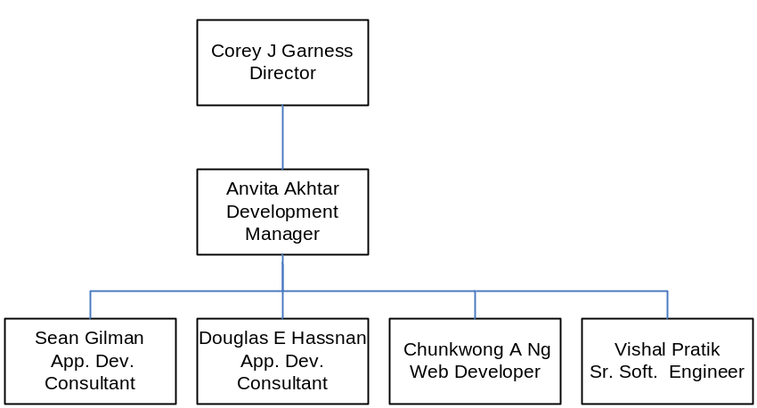

Abbreviations -

Sr. Soft Engineer → Senior Software Engineer
App. Dev. Consultant → Application Development Consultant

